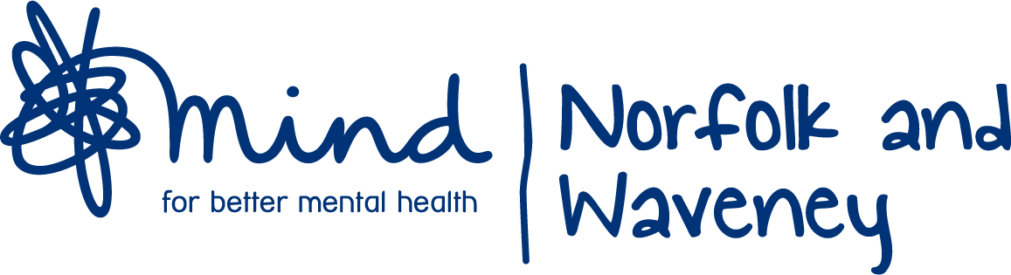

Social Community Contact Form

Safe Haven …………. G4H………………. Social Activity group ………………….

Name: Age:
………………………………………………………………………………. ………………………………………….

Gender F M Other Preferred pronoun she/her him/he they /them

Address:
………………………………………….. …………………………………………….

………………………………………….. …………………………………………….

Postcode……………………………….
Tel no : ……………………………………

Email:

Preferred method of contact - text phone email zoom letter

Emergency contact details Name……………………………… Relationship………………

Contact No ………………………………………….

How can we best meet the person’s needs? Are there any areas of particular interest or concern?

How did you hear about us ?

Equal Opportunities Monitoring Form

Ethnicity To which ethnic group do you consider you belong?

 | White – British |  | White – Irish |  | White – Other
 | Mixed – White & Black Caribbean |  | Black or Black British – Caribbean |  | Black or Black British – Other
 | Mixed – White & Black African |  | Black or Black British – African |  | Mixed – White & Asian
 | Asian or Asian British |  | Asian or Asian British – Pakistani |  | Asian or Asian British – Indian
 | Mixed – Other |  | Asian or Asian British – Other |  | Chinese
 | Romany Gypsies |  | Irish Travellers |  | Other
 | Prefer not to say

Disability Do you consider yourself to have any of the following disabilities?

 | Learning Disability |  | Mental Health Disability
 | Physical Disability |  | None

Sexual Orientation

 | Heterosexual |  | Gay Man |  | Lesbian
 | Bi-sexual |  | Prefer not to say

Religion

 | Buddhist |  | Hindu |  | Other
 | Catholic |  | Jewish |  | Protestant
 | Church of England |  | Sikh |  | None
 | Prefer not to say

How we process the information you provide
We take your privacy seriously and promise to never sell your data. You can find out more about your rights, how we use your personal information and how we keep your details safe and secure by reading our Privacy Statement. For more information, to update your choices or to stop us sending you updates contact us on 01603 432457 or enquiries@norfolkandwaveneymind.org.uk

I agree to the use of my data as described above, and agree to my referral to West Norfolk Mind

Service User signature ………………………………...…………… Date………………………

NWM signature ………………………………...…………… Date………………….……
NWMind office use only
Date received |  | Received by
 |  | Approved by
Documents received | CPA Y/N | Risk Assess Y/N | Crisis Plan  Y/N | Other:
Allocated to |  |  | Date 1st contact made

